Full-Time Staff Template (Exempt)
**The last day to submit an application for this position is, <DATE> by 11:59pm MST. **
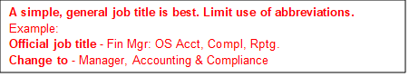
Job Title (keep bolded)
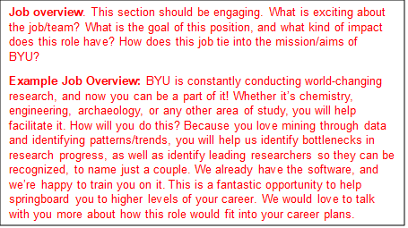
Enter job overview paragraph here...
What you’ll do in this position:
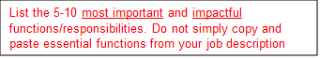
- …
- …
- …
What qualifies you for this role:
Required
- A firm commitment to the mission of BYU.
- Minimum educational requirement
- Minimum experience requirement
- Any required licenses, certifications, etc.

Preferred
- Preferred education
- Preferred experience
- Continue list with skills, abilities, etc.
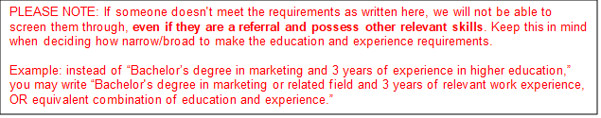
*Use this section ONLY if a physical exam is required
Physical Exam and Lift Test Required
Physical Effort (You can find this on the last page of the job description. Please select correct bullet point and delete the others.)
- General office or other equivalently good environment (No further detail necessary)
- Rare presence of abnormal variations in temperature and exposure to outside conditions (No further detail necessary)
- Periodic exposure to unfavorable conditions because of unavoidable need to be in variable temperatures or wet environments, etc. (Elaborate below)
- Frequent exposure to unfavorable conditions such as all-weather, or working in cramped, very dirty, or unpleasant quarters (Elaborate below)
- Predominant exposure to very disagreeable surroundings (Elaborate below)
Environment (You can find this on the last page of the job description. Please select correct bullet point and delete the others.)
- General office or other equivalently good environment (No further detail necessary)
- Rare presence of abnormal variations in temperature and exposure to outside conditions (No further detail necessary)
- Periodic exposure to unfavorable conditions because of unavoidable need to be in variable temperatures or wet environments, etc. (Elaborate below)
- Frequent exposure to unfavorable conditions such as all-weather, or working in cramped, very dirty, or unpleasant quarters (Elaborate below)
- Predominant exposure to very disagreeable surroundings (Elaborate below)
Hazards (You can find this on the last page of the job description. Please select correct bullet point and delete the others.)
- Minimal existing or potential hazards (No further detail necessary)
- Moderate existing or potential hazards (Elaborate below)
- Frequent existing or potential hazards (Elaborate below)
Physical Requirements (You can find this information on the last page of the job description at the very bottom. Please take the information from the matrix and bullet point them below.)

What we offer in return:
This position comes with fantastic benefits, including:
- 401k. BYU automatically contributes 8% at no cost to you. Additionally, if you contribute 5%, BYU adds an additional 4% (Rehires may qualify for different retirement plans)
- Excellent work-life balance: 13 paid holidays + 22 days paid vacation + 12 sick days, accrued annually
- Employee assistance program, available to the employee and all members of their household
- Tuition benefits for employees and eligible family members
- Access to athletic facilities
- Excellent medical/dental benefits
- Short/long-term disability benefits
- Paid parental and maternity leave
- Wellness Program
- Free on-campus parking
- Free UTA passes for employees, spouses, and qualified dependents
- Discounts at the BYU Store and for many events at BYU

Pay Grade:
Typical Starting Pay:

The actual compensation offered will take into consideration internal equity and may vary based on the candidate’s job-related experience, knowledge, skills, and other relevant factors. Candidates with very significant work-related experience may receive an offer higher than the posted typical range.
**If the job doesn’t have a post-end date, the job could close at any time on any day**

