½-Time (PT Non-Benefited) Template
**The last day to submit an application for this position is, <DATE> by 11:59pm MST. **
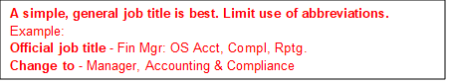
Job Title (keep bolded)
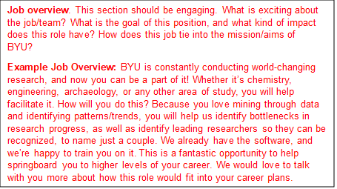
Enter job overview paragraph here...
Note: This is a part-time position (10, 15, 17.5, 20) hours per week.
What you’ll do in this position:
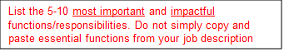
- …
- …
- …
What qualifies you for this role:
Required
- A firm commitment to the mission of BYU.
- Minimum educational requirement
- Minimum experience requirement
- Any required licenses, certifications, etc.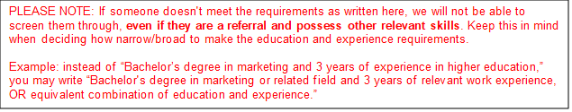
Preferred
- Preferred education
- Preferred experience
- Continue list with skills, abilities, etc.
What we offer in return:
This position comes with fantastic benefits, including:
- Employee assistance program, available to the employee and all members of their household
- Access to the library
- Free on-campus parking
- Free UTA pass
- Discounts at the BYU Store and for many events at BYU
Pay Grade:
Typical Starting Pay:
The actual compensation offered will take into consideration internal equity and may vary based on the candidate’s job-related experience, knowledge, skills, and other relevant factors. Candidates with very significant work-related experience may receive an offer higher than the posted typical range.
**If the job doesn’t have a post-end date, the job could close at any time on any day**

