e-Recruit Desk Reference
The new system is based in PeopleSoft so before gaining access to the system you must request security access through your department’s security access coordinator. A list of coordinators for each department can be found here…
https://hrms.byu.edu/psp/ps/EMPLOYEE/HRMS/c/Y_HIDDEN.Y_SAC_LIST.GBL
PLEASE NOTE Please be aware that anyone who will either need to post positions OR approve postings will need to be granted security access. Those who will only need to view applications must be entered into the hiring managers field on the” create job posting” – view only users do not need security access, however you must add them to the hiring manager field. Although you may submit requests for everyone who may potentially need access, it is recommended that you submit requests on an as-needed basis.
How to Login
To access the system, go to hrms.byu.edu. Login, then access the employment portal by clicking…
- Main menu
- BYU menu
- Staff Employment
- Staff Employment Portal
When there, you should see the following…
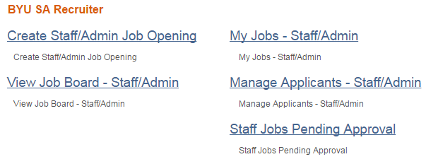
View Job Board
By clicking “view job board” you will be able to see the applicant’s view of the system and check to see if you job is posted and review all active job postings. Note the filters on the left side of the page. By clicking each filter, the page narrows the search and shows only those positions that match the criteria you have entered.
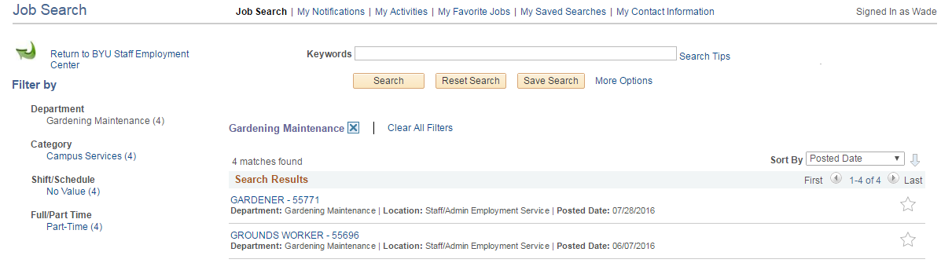

Create Staff/Admin Job Opening
Begin by entering the following criteria that will determine what information will be required on your posting.
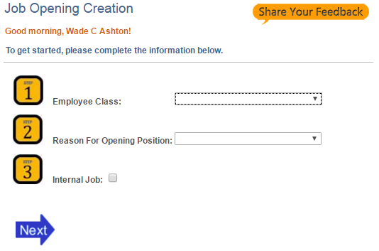

Be sure to select the correct class. If you continue entering the posting and want to change the class, the system will make you re-enter the posting, beginning at this page.

Note that you will rarely, if ever, mark a position as “Internal Job.” The feature is here ONLY for positions that have been approved to be posted for BYU employees only or for employees within a specific division or department. Contact HR if you have received approval for an internal-only job posting. Vice President approval is required.

After clicking “Next” there are three sections that must be completed before submitting a job for posting….
- Position Data
- Description and Questions
- Posting Description
A brief description of the fields on each page will be provided in the following pages but if you have further questions, please contact the Staff and Administrative Employment office at 422-3563for assistance in completing/submitting your job posting.

Position Data
Job Category (required field): click the magnifying glass icon and select the job category that most closely matches the position you intend to post. If not related to any listed, click miscellaneous.

Select the position number you intend to use (note that only ¾ time and full-time positions have numbers associated with them). If you don’t know the position number, contact your HR Consultant. http://www.byu.edu/hr/?q=directory/area-hr-consultants. Click the + sign if you are posting multiple positions on the same job posting

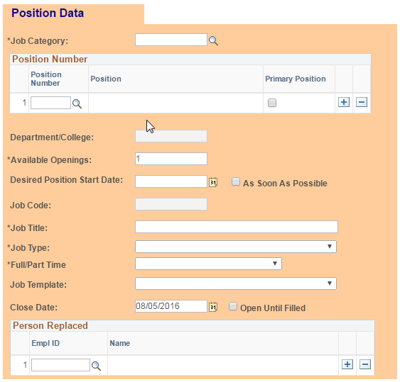

Internal use – no need to check/uncheck this field

Dept/College pre-fills based on the position number you selected. Cannot edit.

Available Openings defaults to 1. Change as needed.

Job Code pre-fills based on the position number you selected. Cannot edit.

Job Title pre-fills but you may edit the title, if needed.

Job Type is used for applicant search. Select the most applicable.

Job Templates are available for SOME positions and pre-fills the position description with some recommended wording. Edit as needed.

Person Replaced. Clilck the magnifying glass icon and select the individual(s) vacating the position (if applicable).

Any item designated with a * symbol is a required field.
Fields with plus and minus icons allow you to enter multiple lines. Example: if filling more than one position based on an identical job description, add lines for each position number being filled. Likewise with people replaced above.

_________________________________

Internal Job is checked only if a Vice President has approved a posting that is viewable only by current BYU employees, either university-wide, division-wide, or department only.

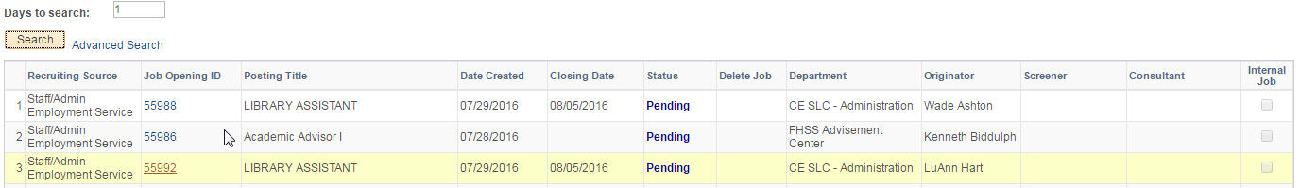
Days to Search – use to limit the number of jobs shown or find a position you posted previously. Use the advanced search if you know the position title or other specific information.
The Status column will show the one of the following stages.
- Draft indicates you have begun creating a job posting, but clicked “save for later” at the bottom of the posting. Always editable.
- Pending indicates that you have clicked submit and the position is in the process of routing to approvers.
- Open – if this has to be explained you probably need to take a vacation.
- Closed – see above.
- Denied – you have submitted a posting but the position did not clear the approvals process.
- Recycled – The posting has passed approvals and routed to the employment office, however, there are corrections that need to be made by the department before posting.
- Cancelled – The department has chosen to close the posting without it being filled.
You will manage your job openings via this page. Here you will see a history of all positions you have posted and their current status.
My Jobs – Staff/Admin

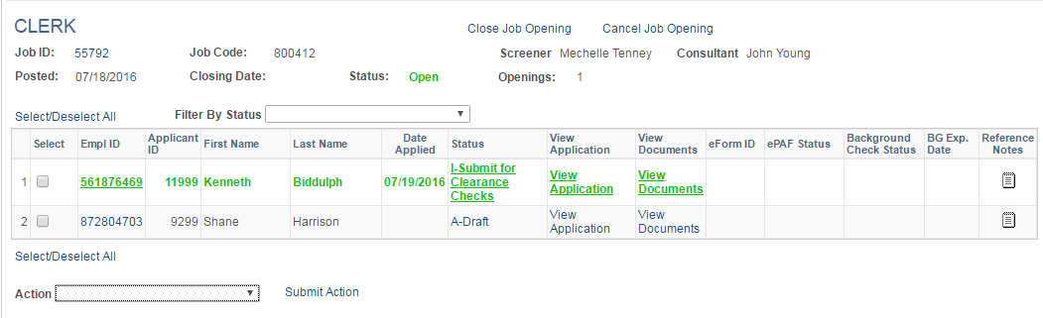
When attempting to open applicant documents, be sure to disable popups in your browser. Documents will open in PDF format.
Change candidate statuses as appropriate by clicking the current status. When selecting your final candidate, select the option “submit clearance checks” and save. An email will automatically route to the employment office requesting that we begin the clearance process.
To change the status of multiple applicants simultaneously, click the check box and select an option in the “Action” drop-down menu - once you’ve made your selection, be sure to click “submit action.”
Click the note icon to enter the feedback you receive from two reference calls (while the candidate is having background checks conducted by our office). After opening the page and entering one reference, click the plus sign at the upper right to enter a second reference and click save.
Here you can review a list of all your current and past postings, as well a list of your applicants, their status, application and associated documents. This is also where you will complete/submit two reference calls for your selected applicant.
Manage Applicants – Staff/Admin

Staff Jobs Pending Approval
Go to this page to check if there are any jobs waiting for your approval.

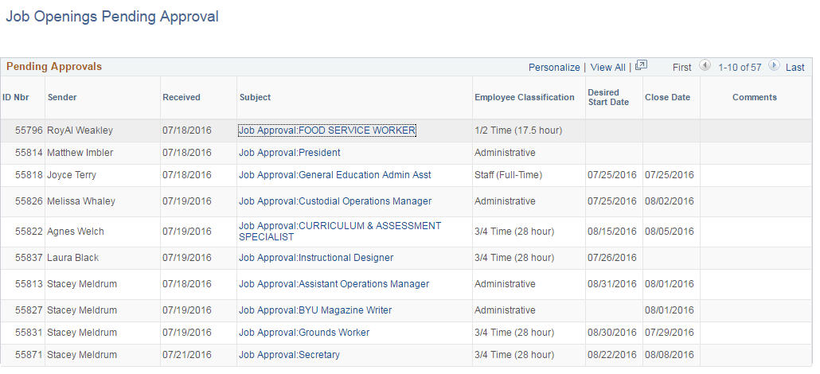

If you have additional questions regarding system functions or need assistance posting your job, please contact our office at 422-3563. We’re happy to assist you.

